Project Increment-2

Smart Learn

**Team members:**

1. Bhavya Sri Sirasanagandlasss
2. Manideep Nadimpelli
3. Raj Marri
4. Sai Harshavardhan Maddula

**Features:**

* Created an animated launch page for the website.
* It leads to Login and Registration components with all the functionalities.
* The User Details were stored in the Mongo Database.
* Added validation messages to display any input validation errors. Used alert messages to display errors.
* Created dashboard page with search bar, which retrieves the top 10 videos of the related search.
* User profile settings modification was implemented, the updating is reflected in the Mongo DB.
* Weekly schedule can be added the syllabus component.

**Implementation:**

1. Created an angular application and also created components.

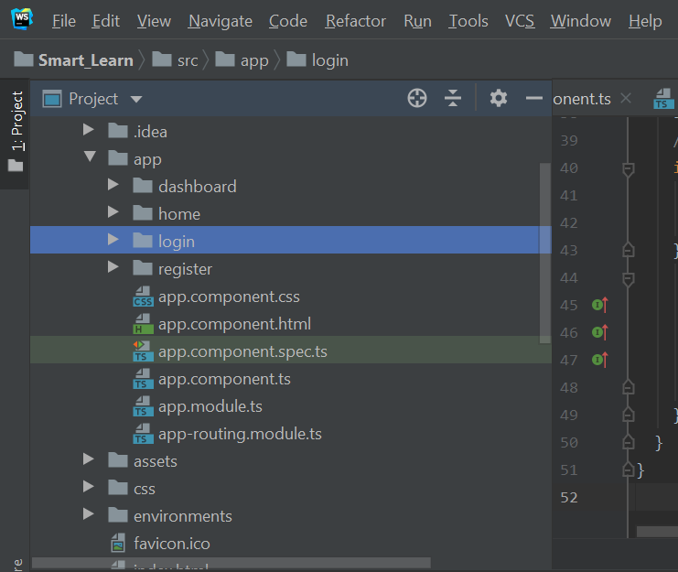

1. For login and registration added form validations.

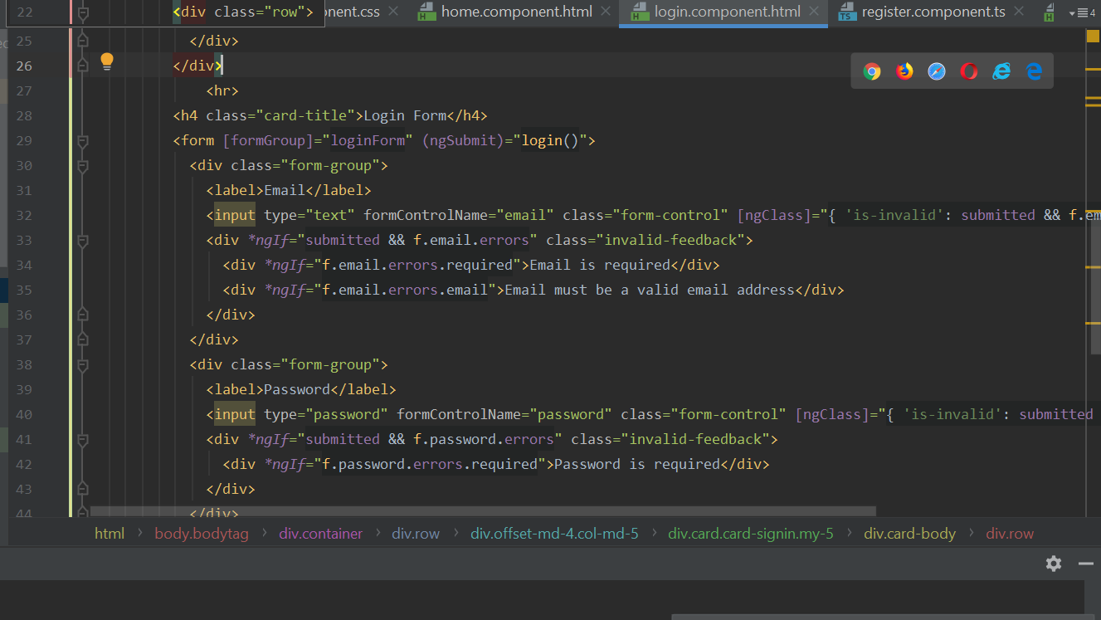

1. Displayed success and error alert messages using sweet alert.

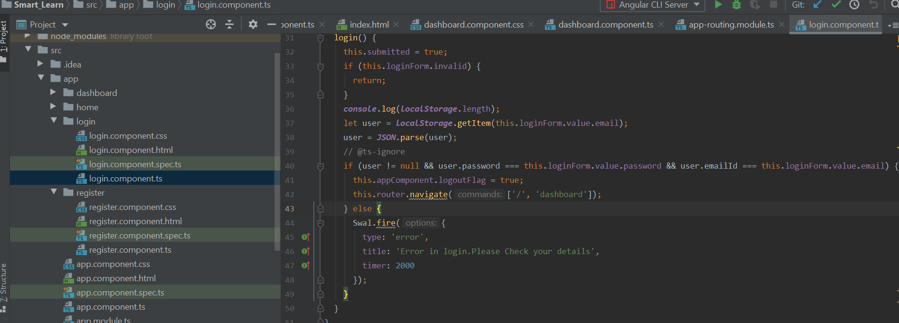

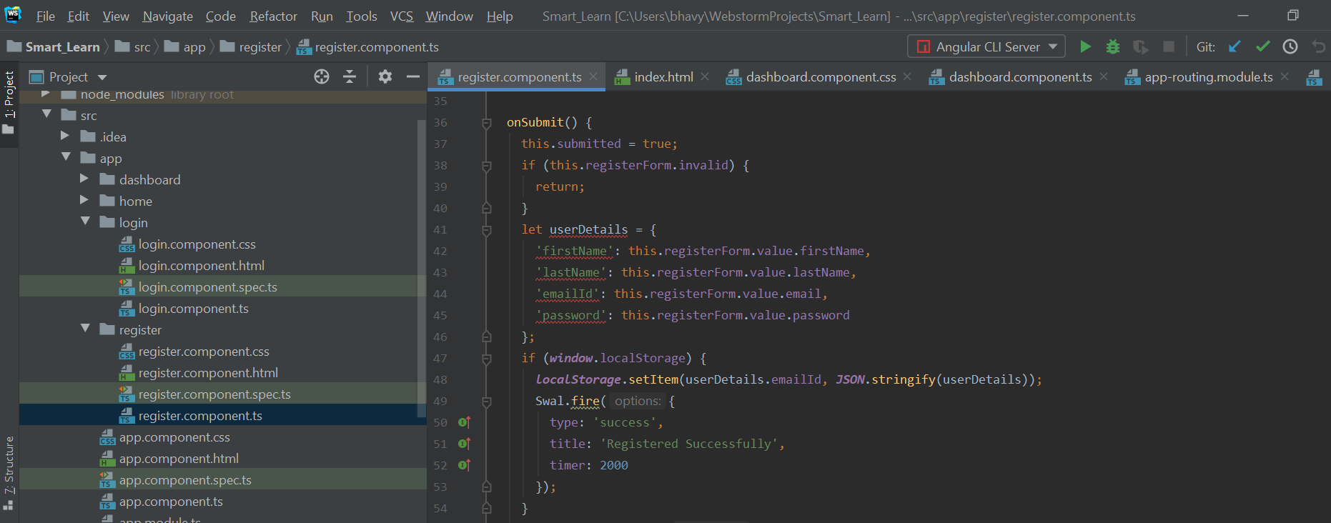

1. Defined routes in Routing module.

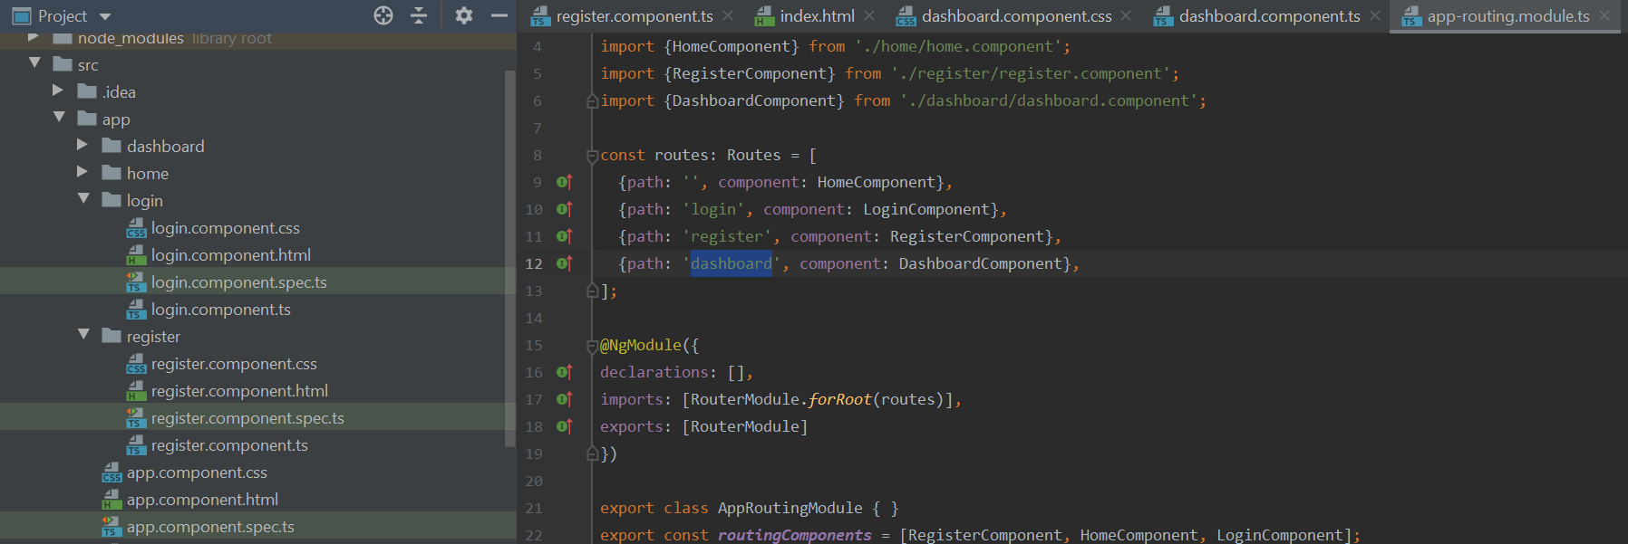

In previous increment we have done login and registration components with respective validations and alert messages. In this increment we have implemented the following features.

1. We have created sidebar and navbar component in components module.

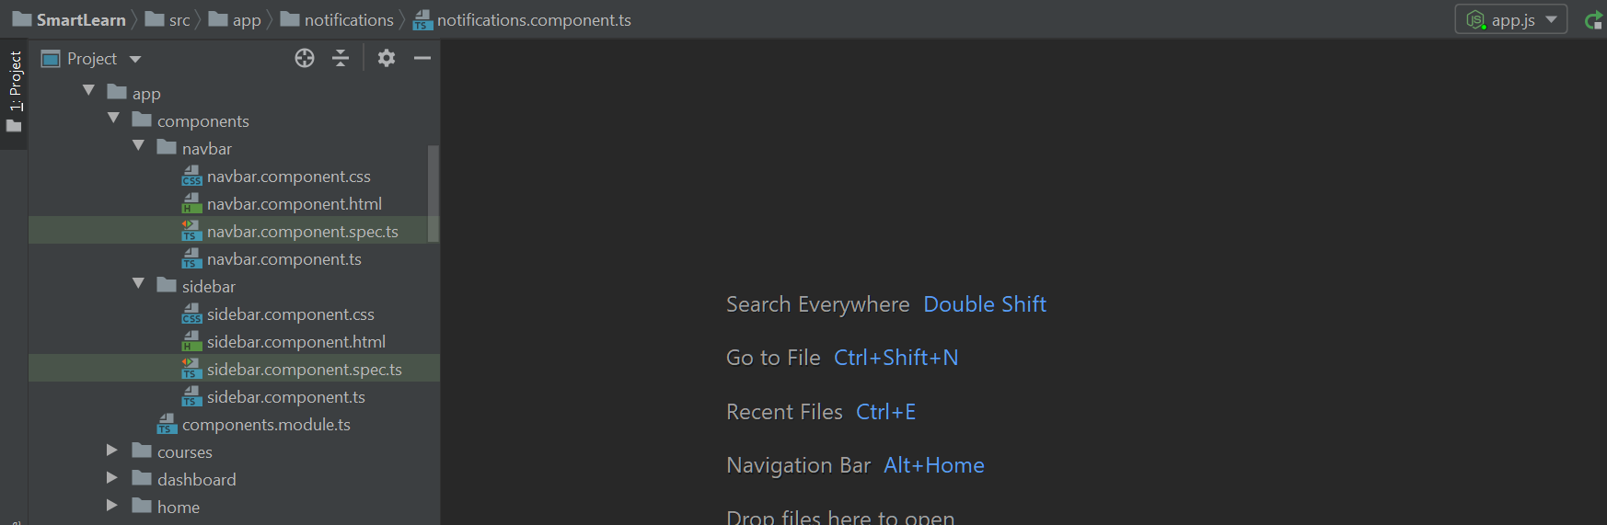

1. Added routing for newly created components.

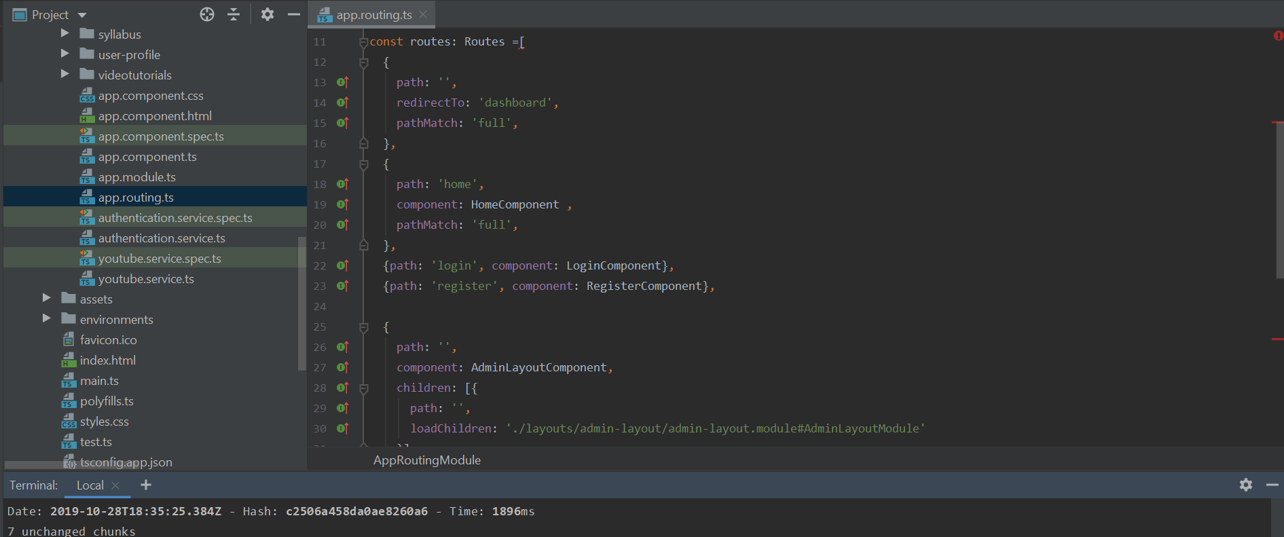

1. For registration and login added authentication using mongo db. We have written service methods for that.

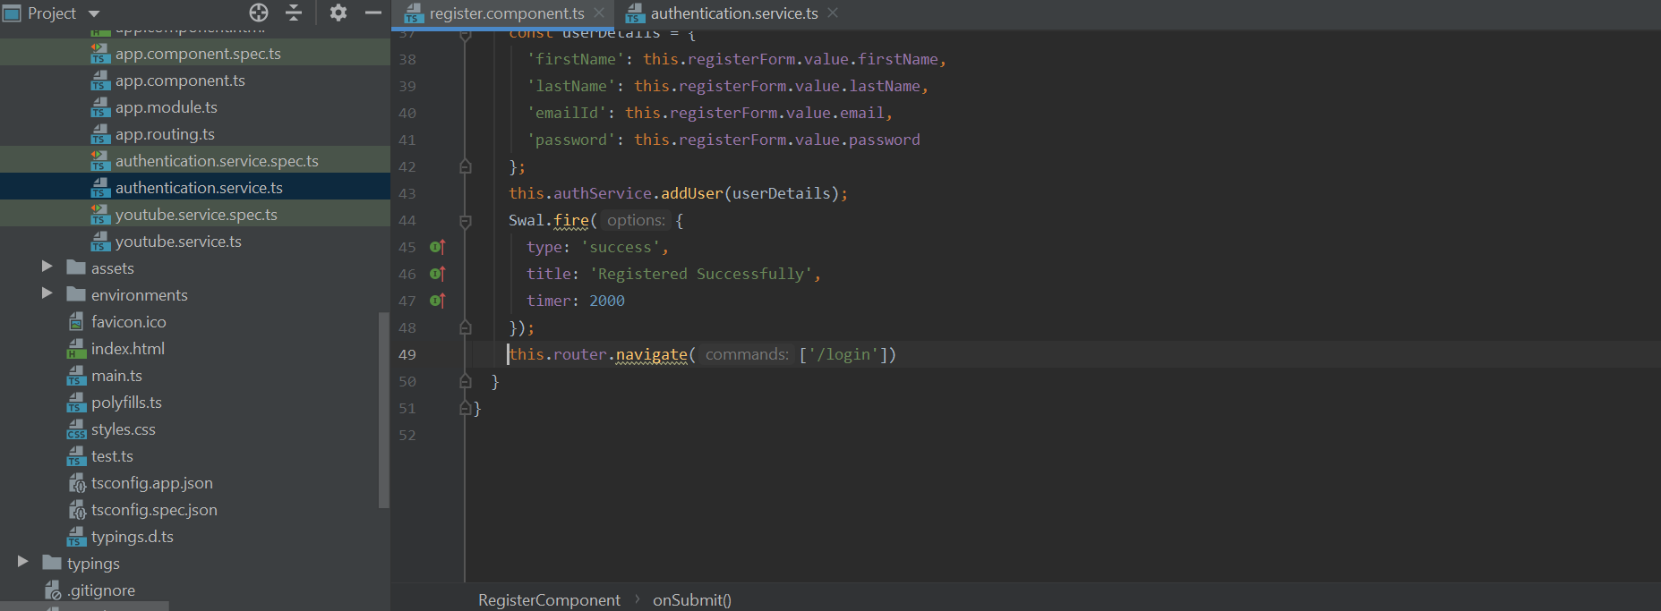

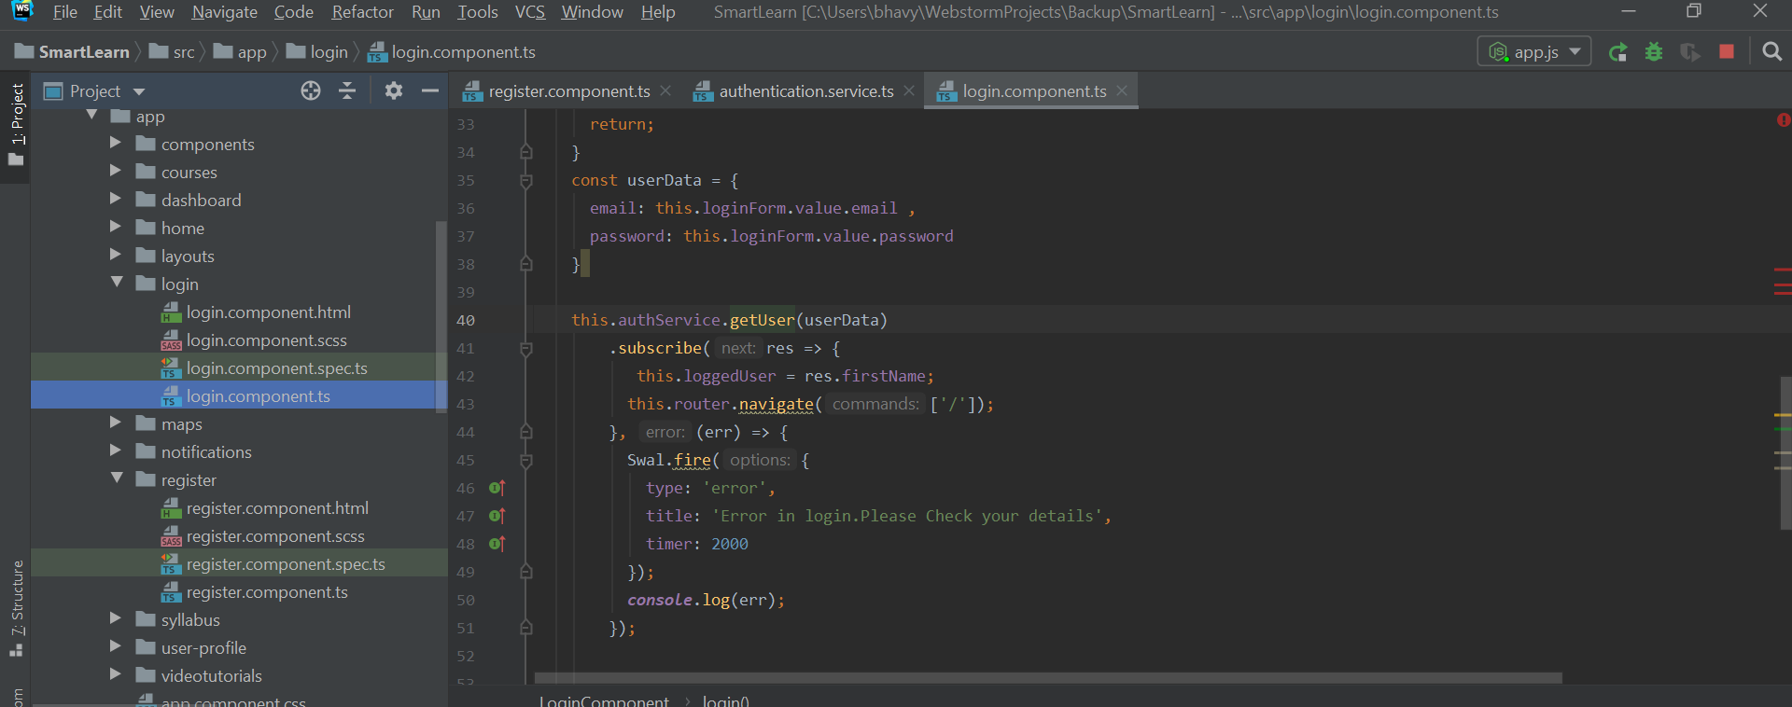

1. Implemented update profile component to update the user data.

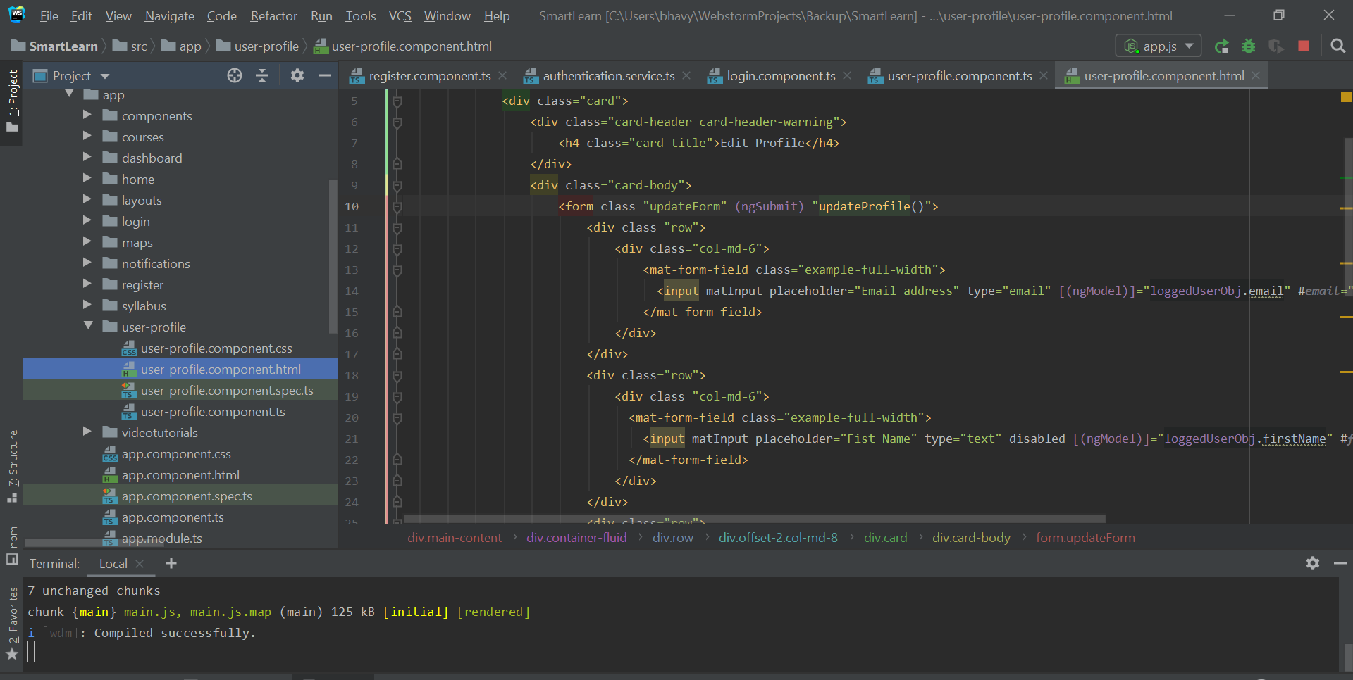

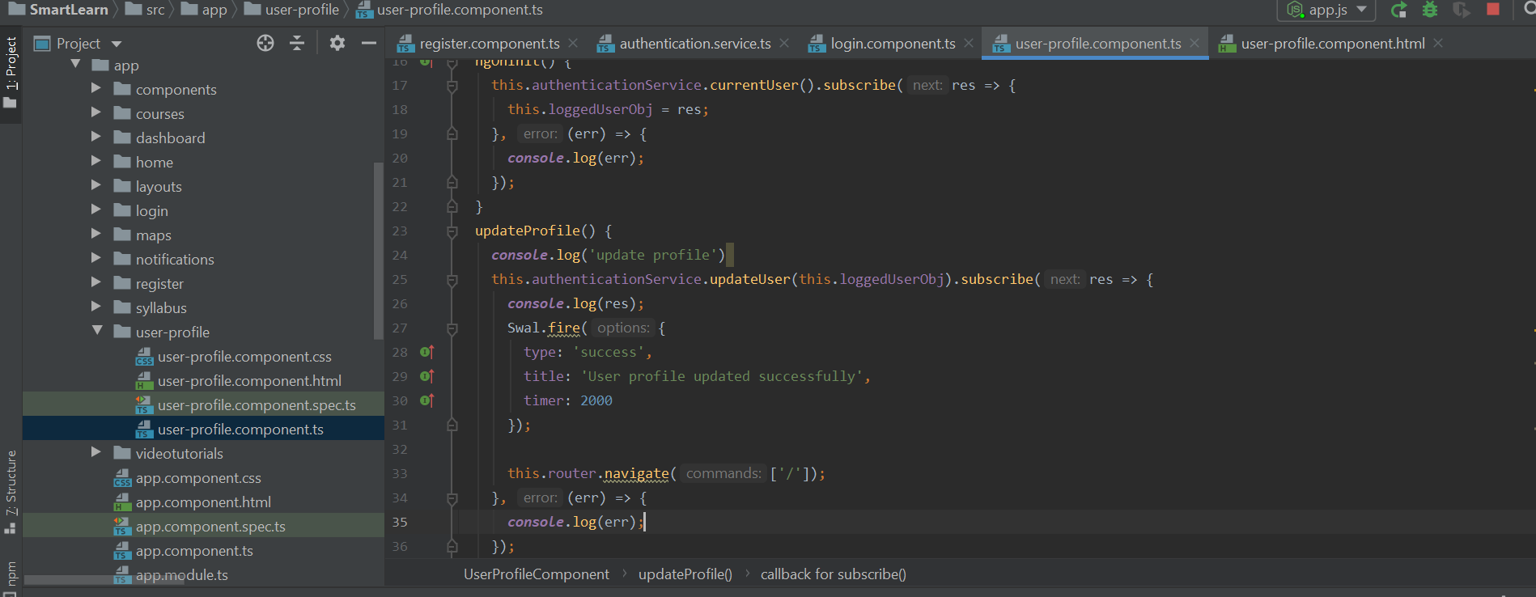

1. In the syllabus component added html code for weekly syllabus. User can add a week or to delete a week.

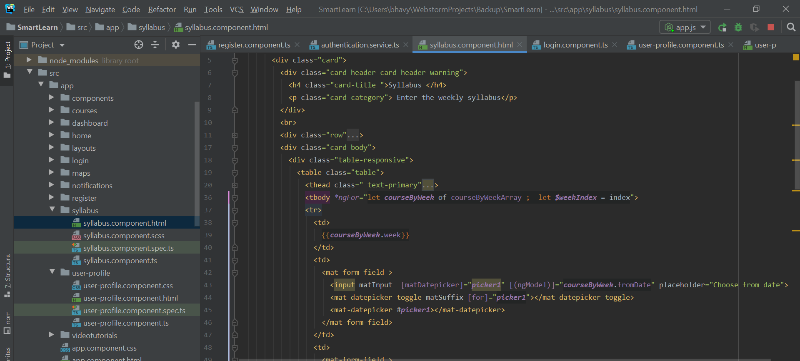

1. Created video component and added code to fetch searched videos. Implemented auto suggestion for search bar.

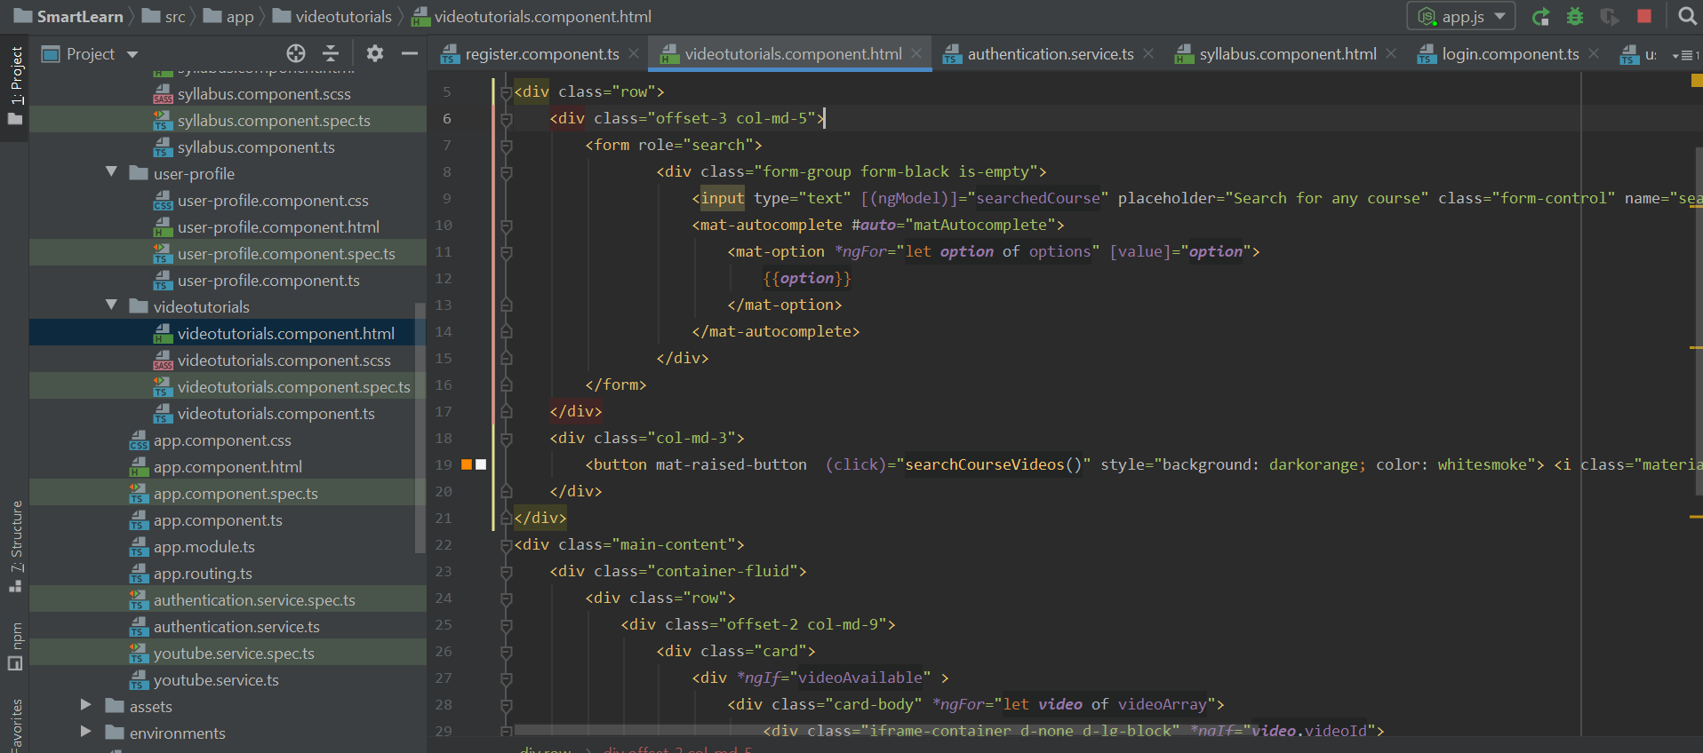

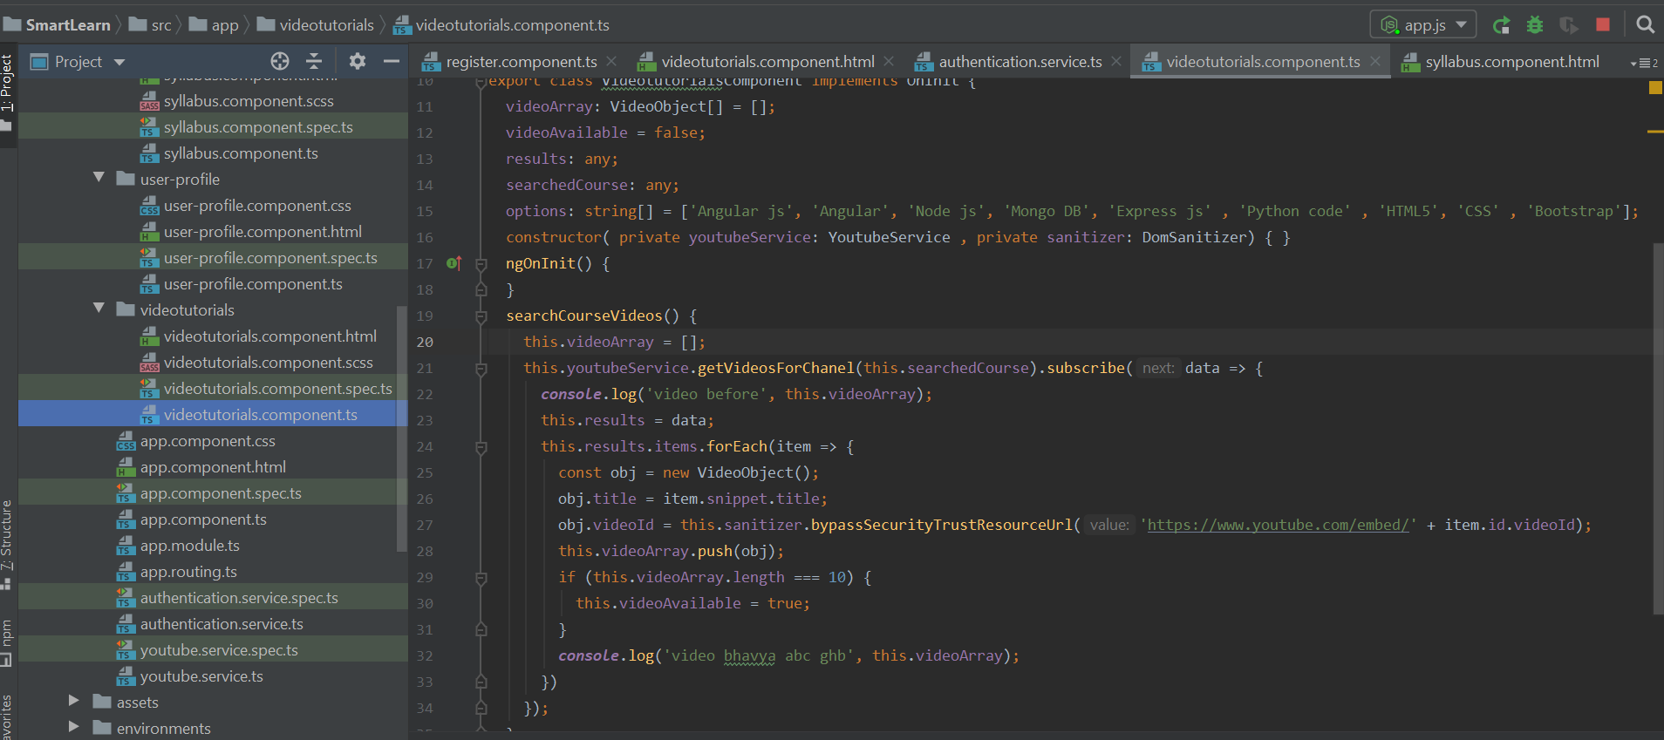

1. Created Backend folder for Mongo DB connection and express js setup. In app.js written code to connect to Mongo DB.

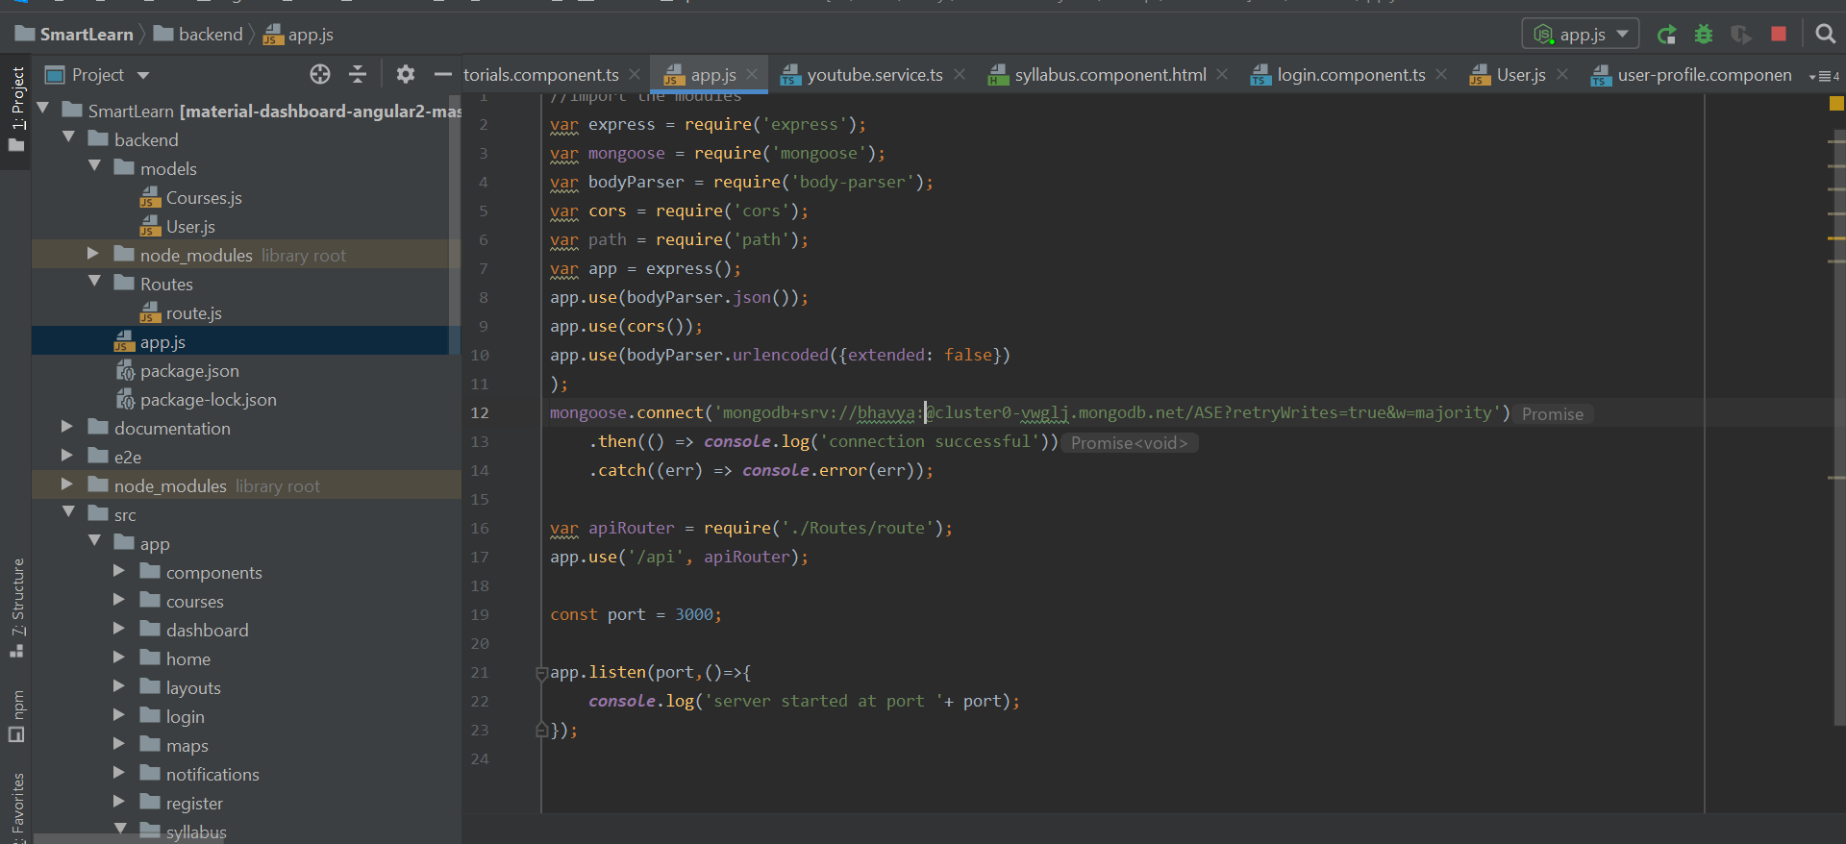

1. Created user schema under models folder.

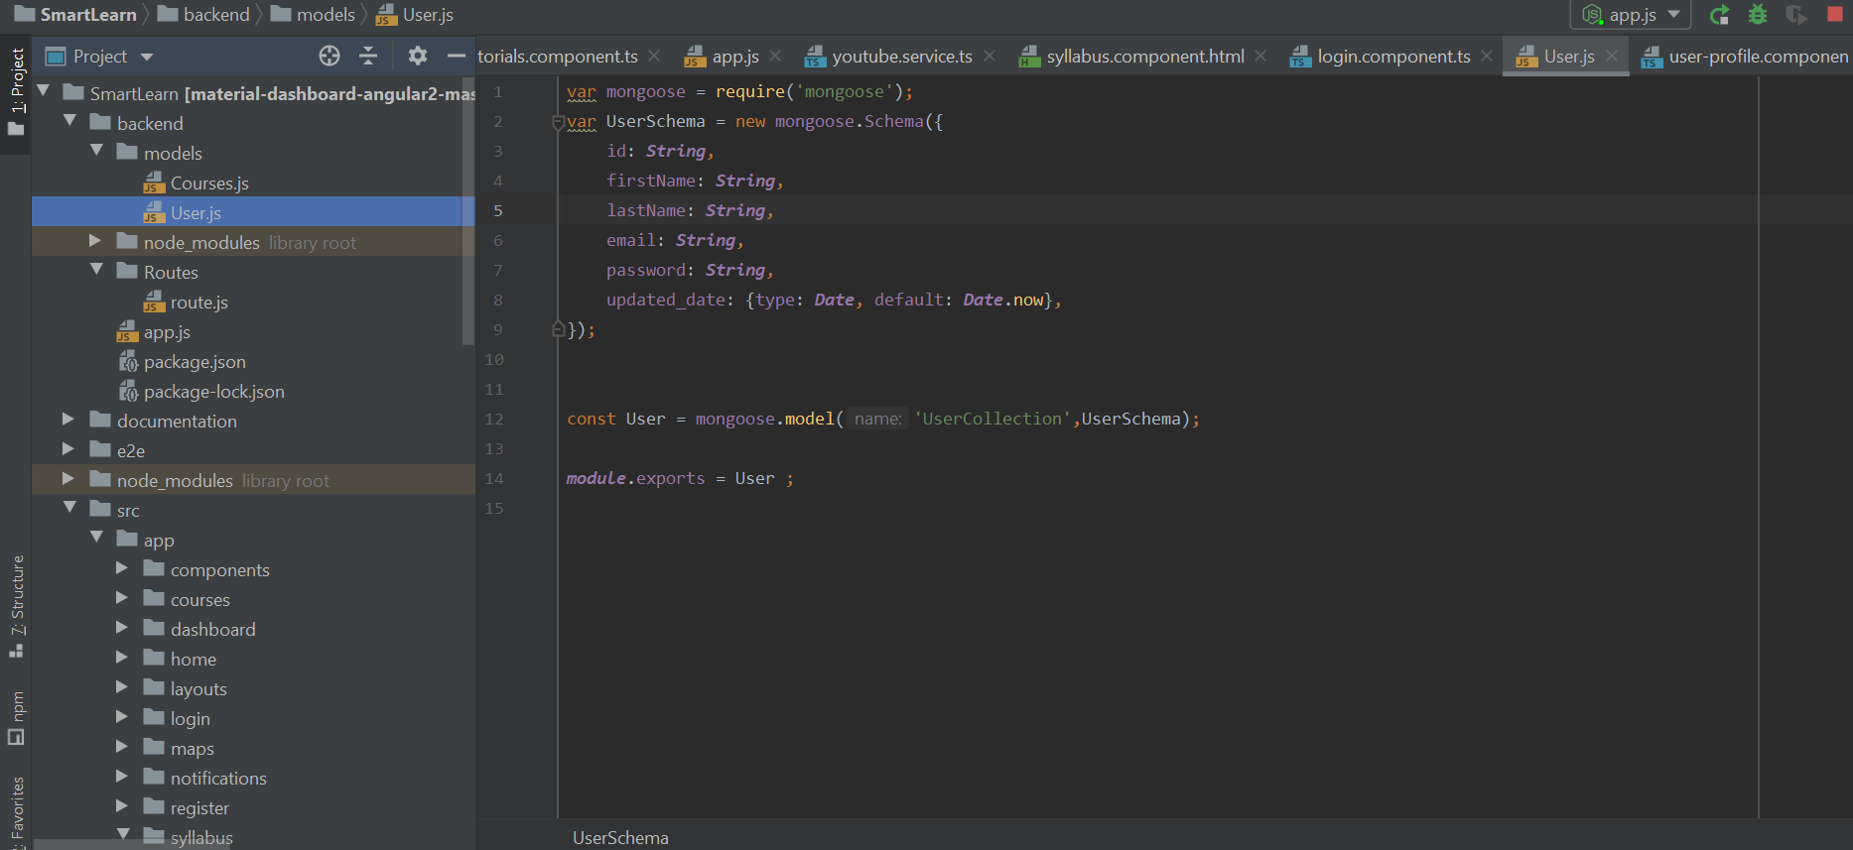

1. Created routes in route.js file.

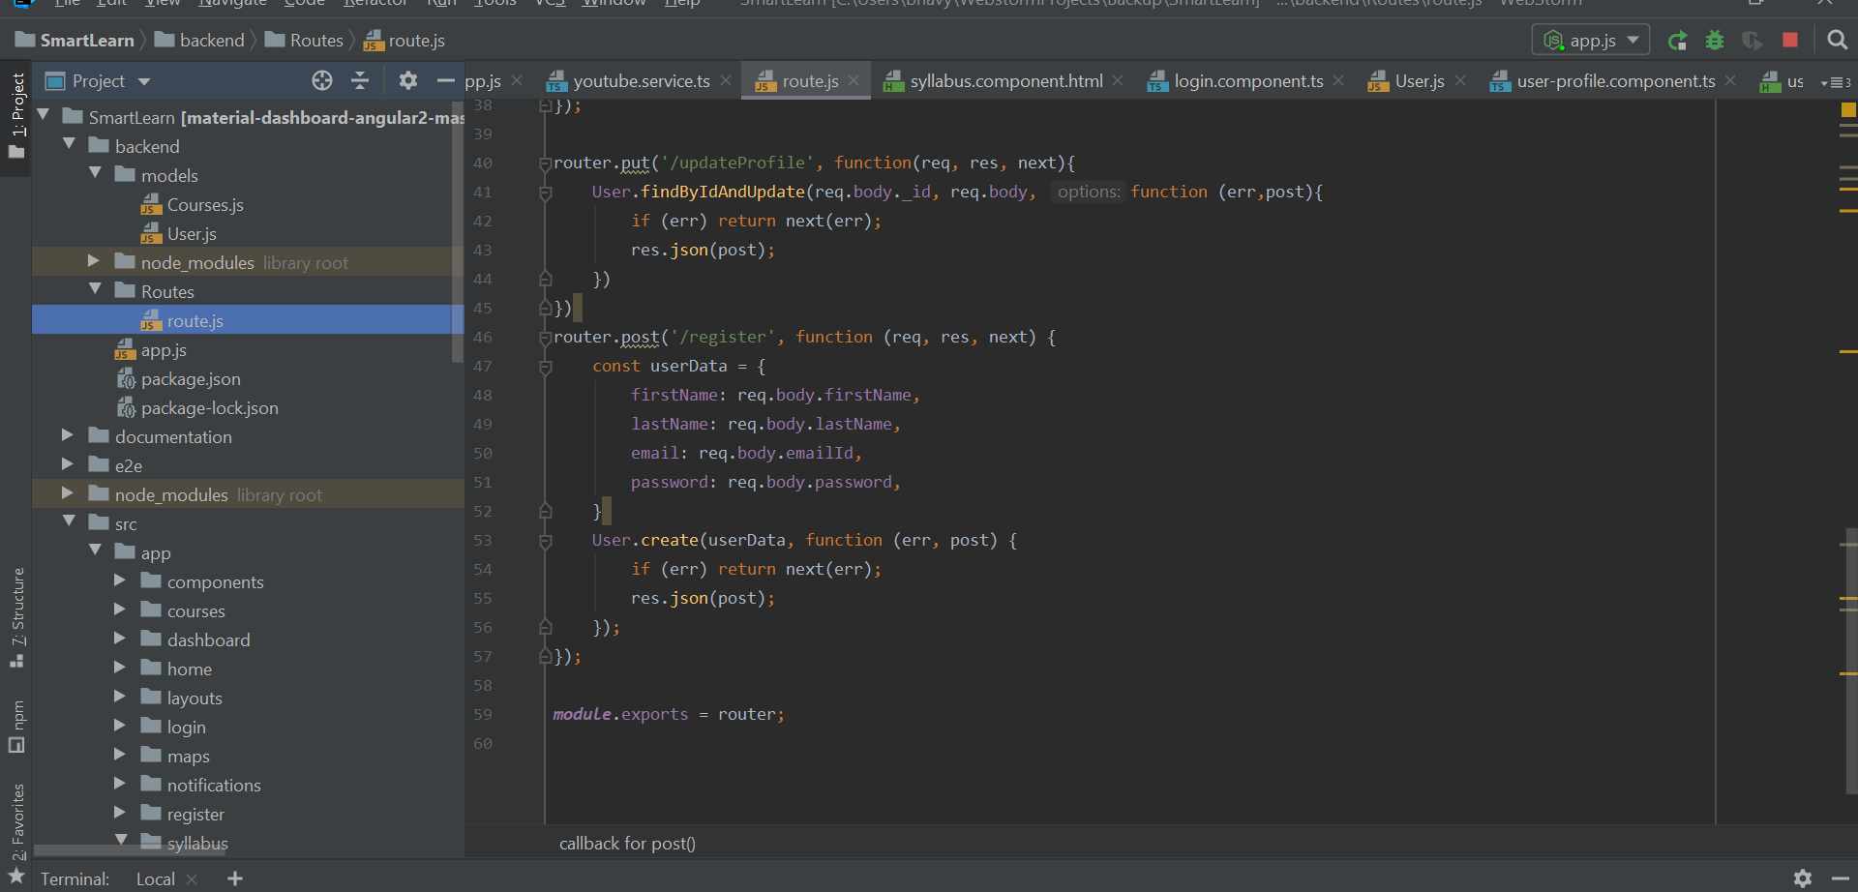

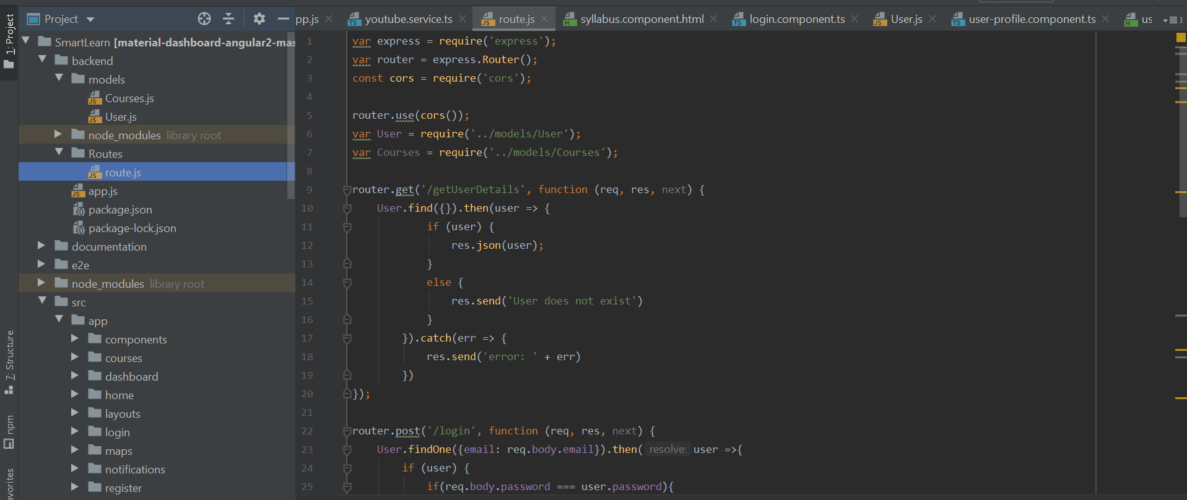

**Design:**

1. Created Logo for our application using freelogodesign.org.
2. When the application starts Launch page will be displayed.

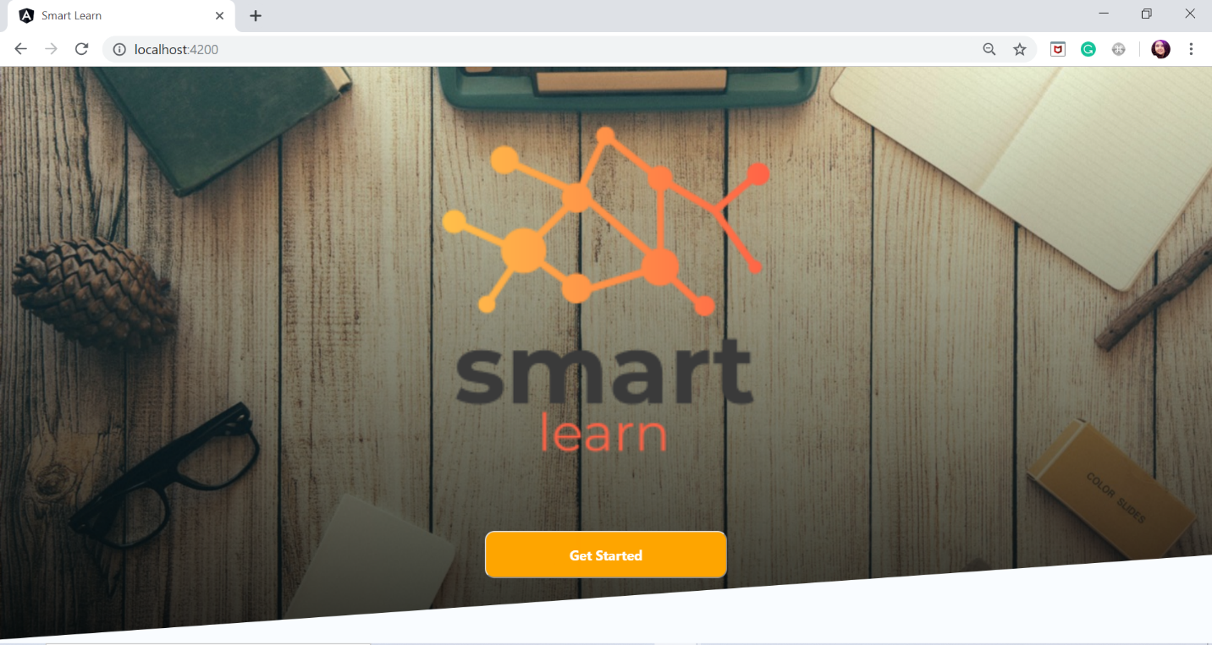

1. When the user clicks on get started button it will navigate to the login page.

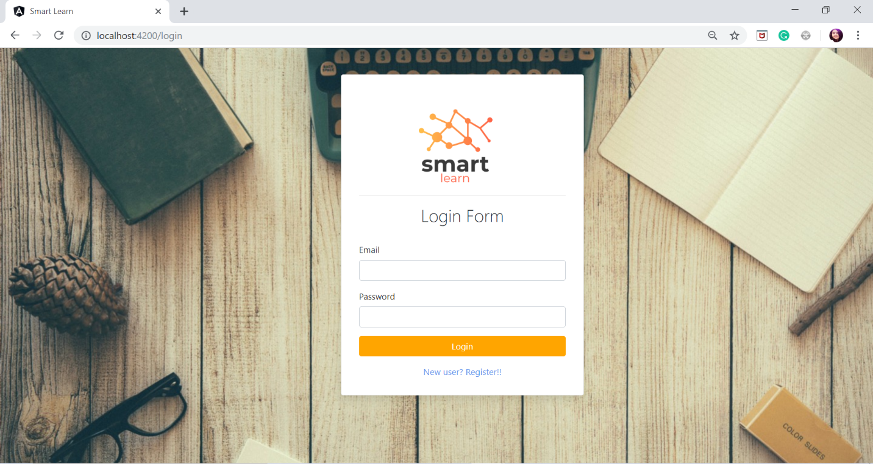

1. When the user entered the invalid credentials, the Error popup is alerted.

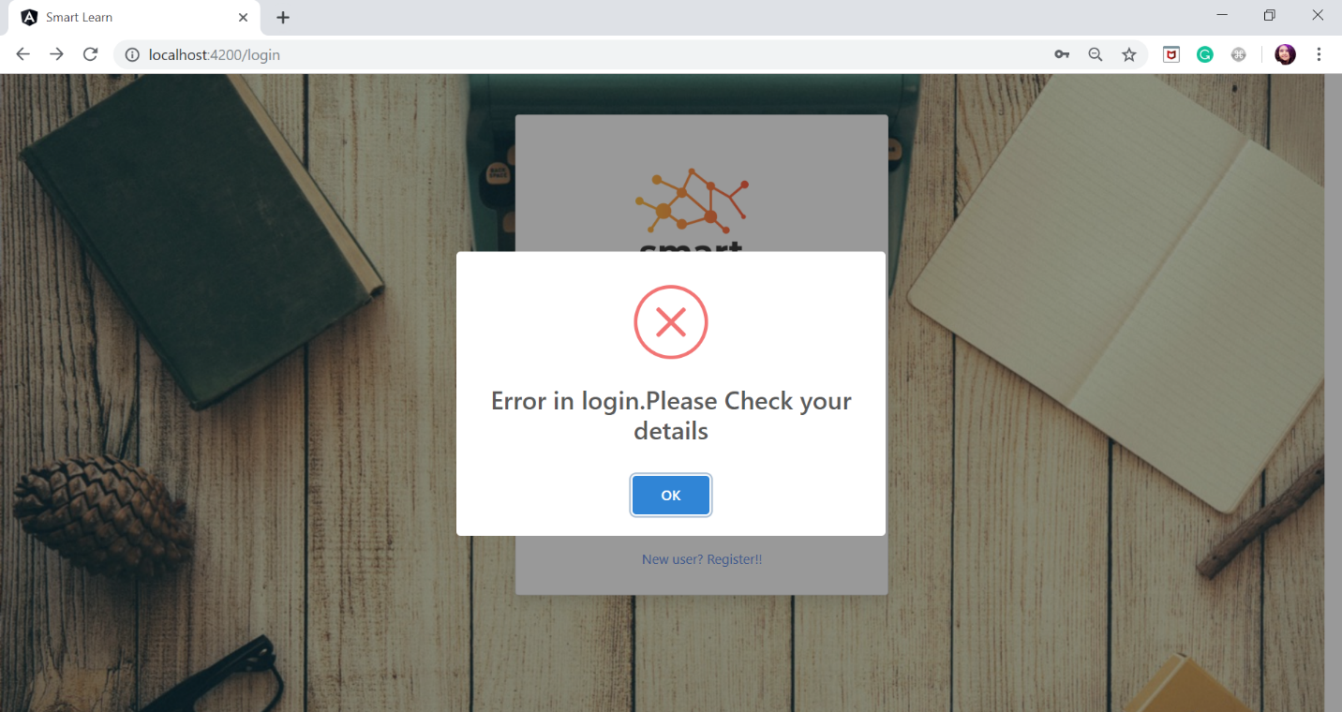

1. When the user registered successfully, the Login Success popup msg is alerted.

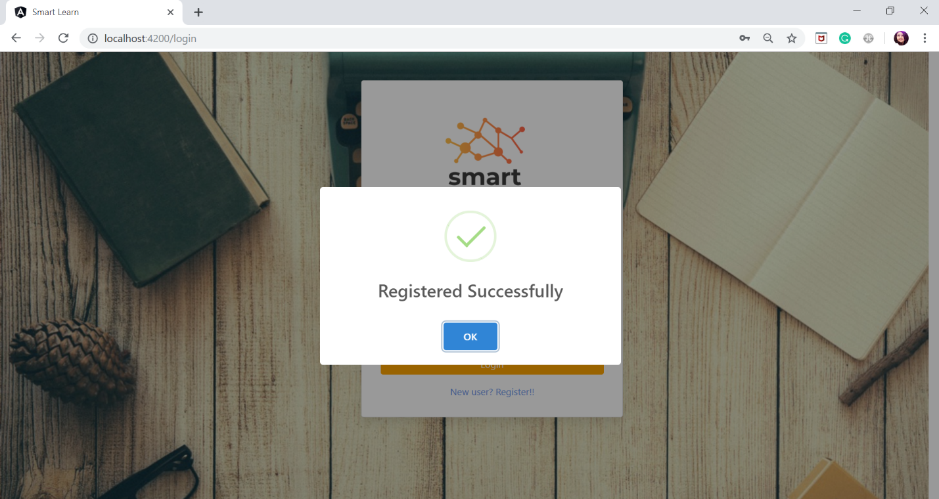

1. All the user credential details are stored in the User collection in the Mongo DB.

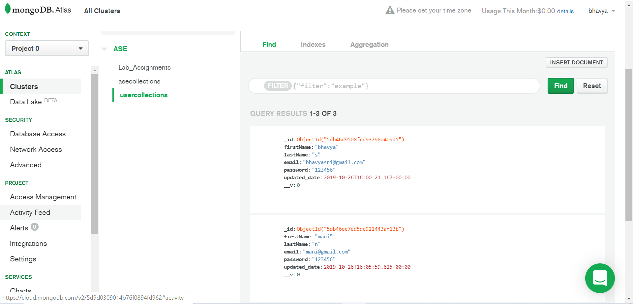

1. When User created an account by registration. The details are stored in the Mongo DB.

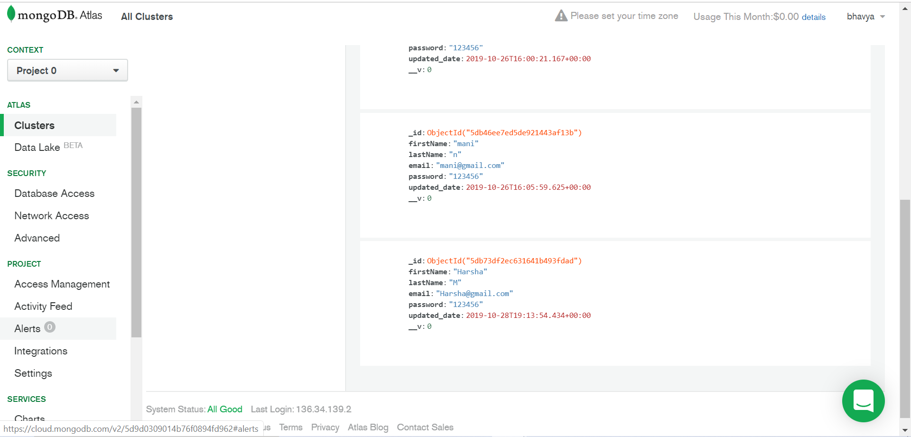

1. User can see and edit his profile details using settings tab in the profile dropdown

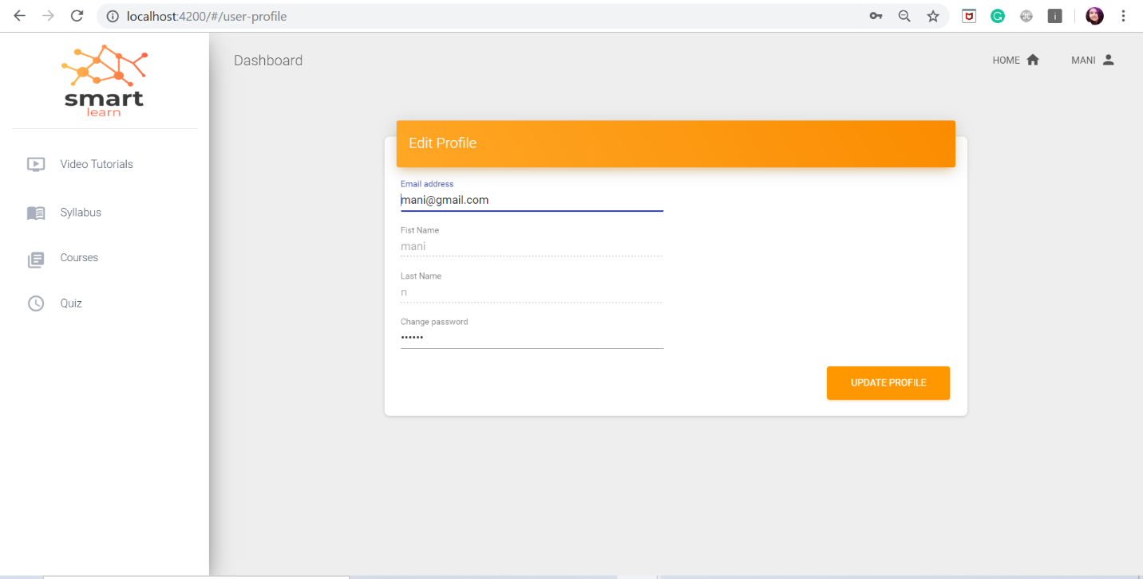

1. Updated profile details are reflected immediately on the profile page.

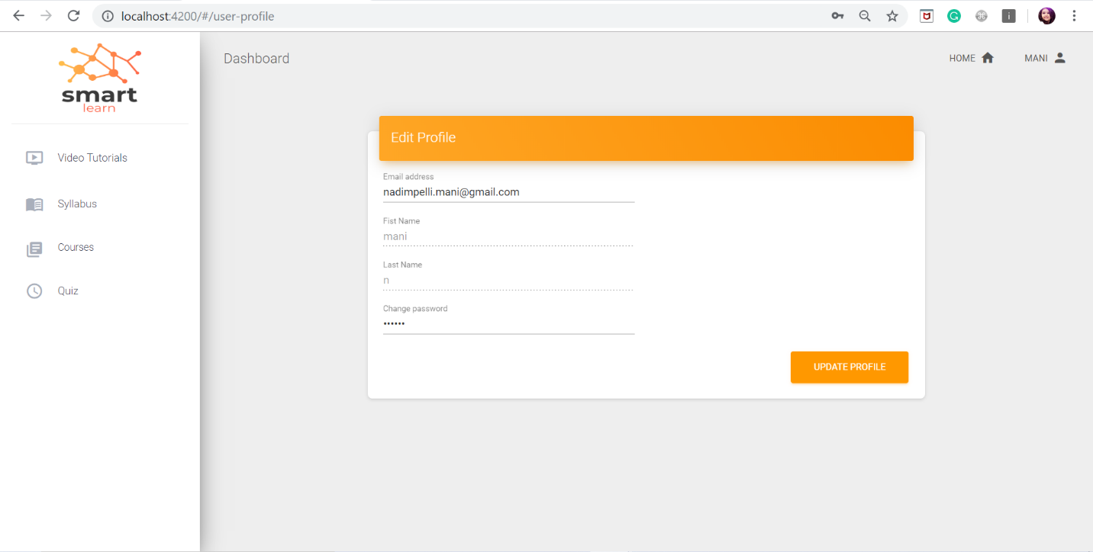

1. After successful updating, an alert with success message is popped out.

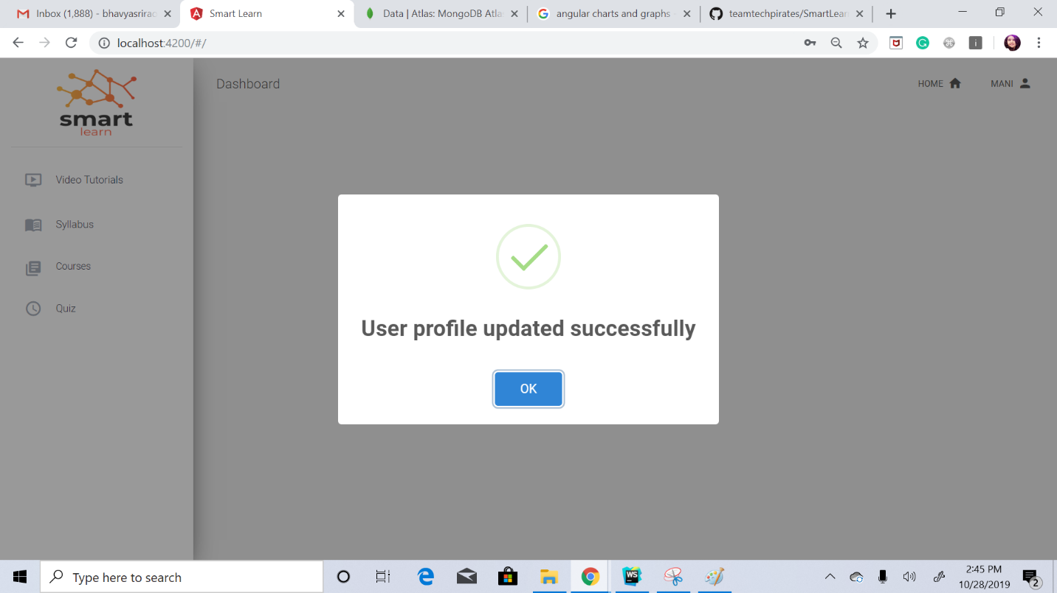

1. The updated details are refreshed with the user’s Db account

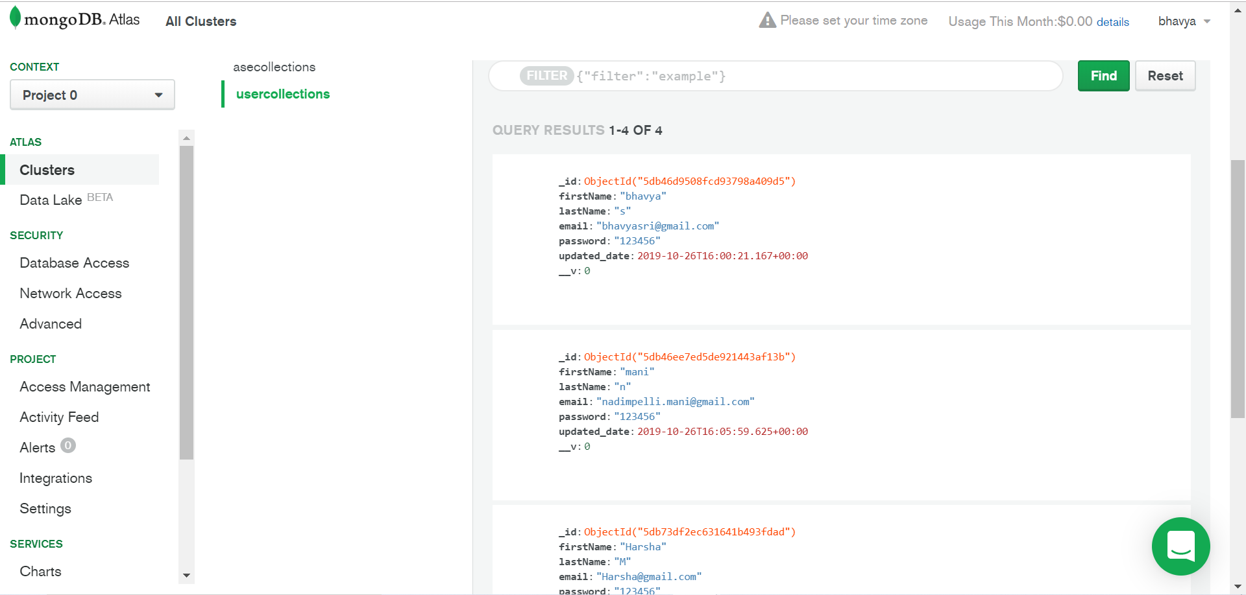

1. Video tutorial component is implemented with search bar.

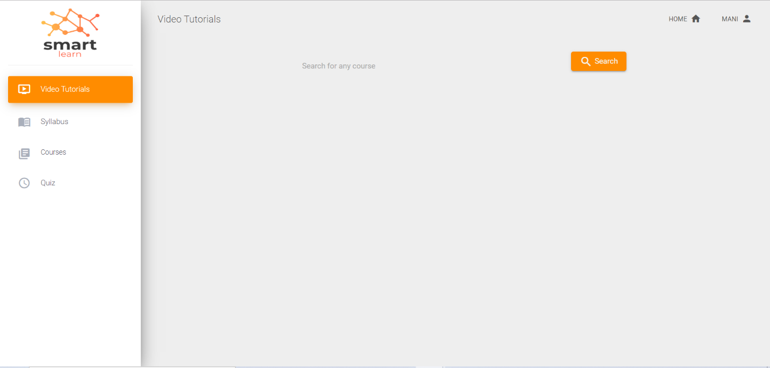

1. In the Video tutorials tab, the Auto suggestions are populated, with a click on the search bar.

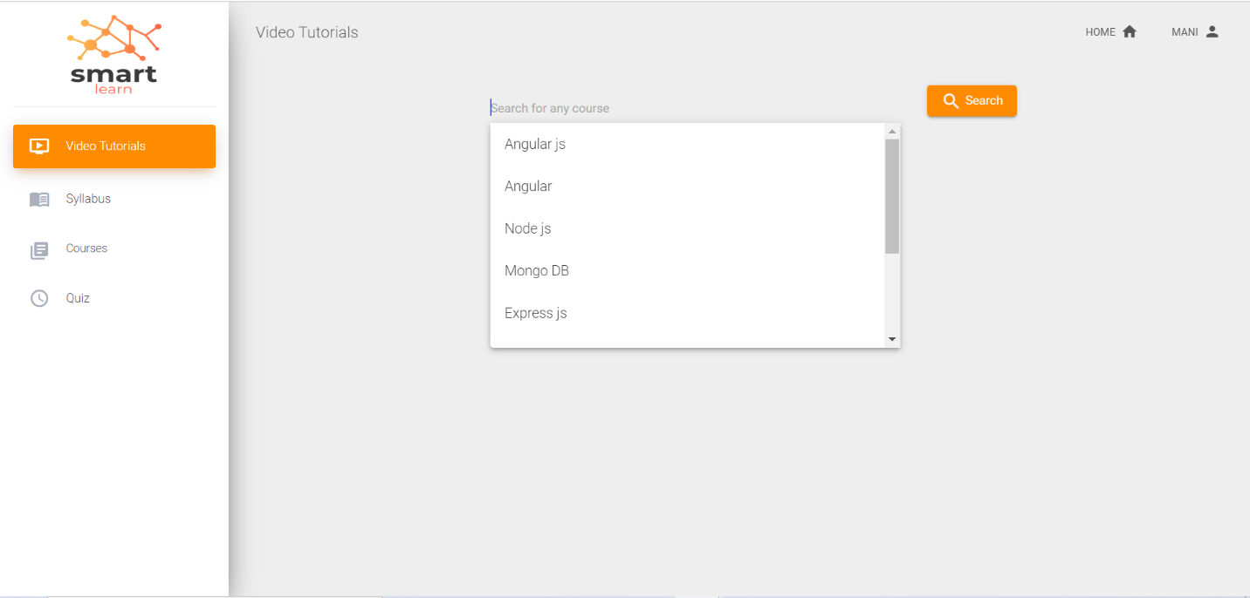

1. After valid search, it displays the top 10 videos of the related search.

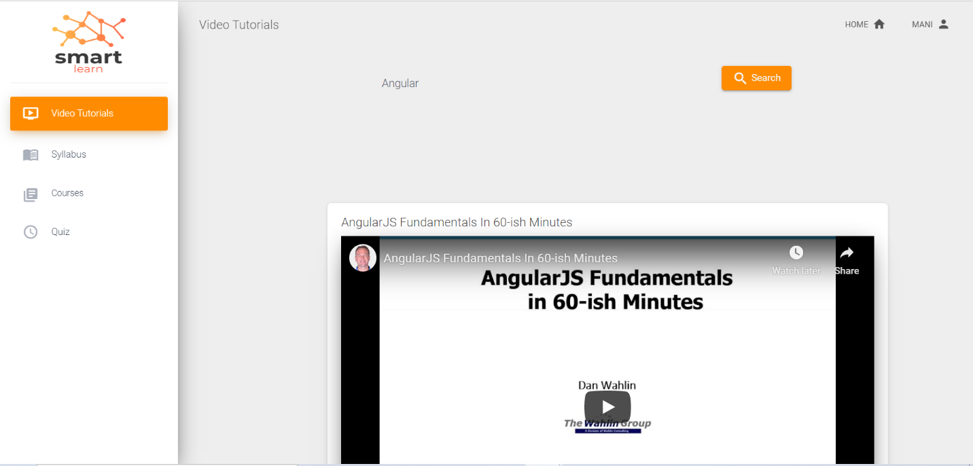

1. Syllabus component UI with schedule updating is implemented. Here user can add a new week and delete a week.

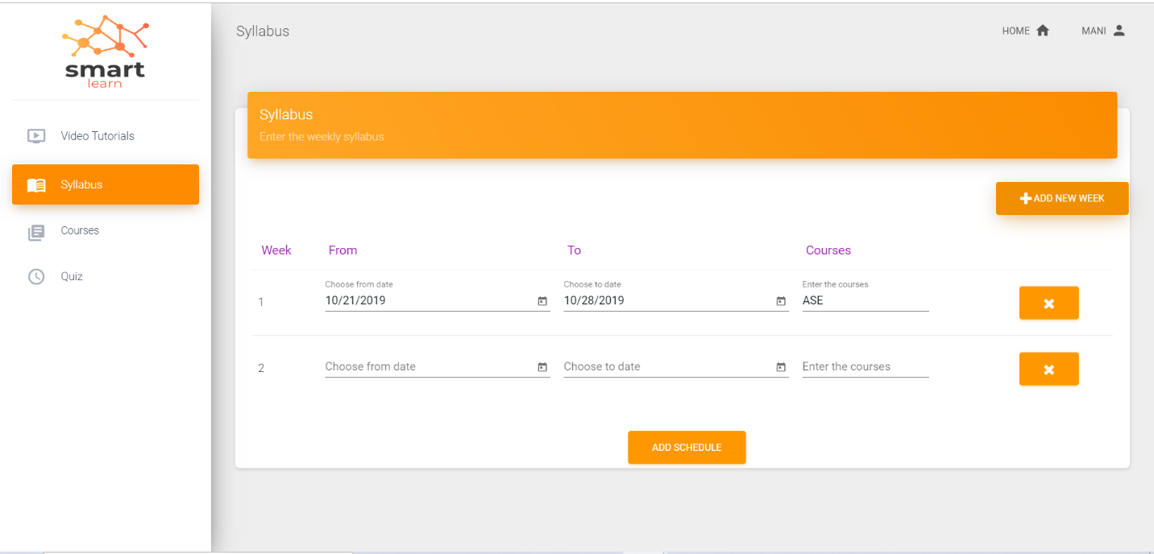

**References:**

* <https://www.w3schools.com/>
* <https://www.freelogodesign.org/>
* <https://sweetalert2.github.io/>
* <https://angular.io/guide/form-validation>
* <https://cssanimation.rocks/>
* <https://getbootstrap.com/docs/4.0/getting-started/introduction/>
* <https://material.io/resources/icons/?style=baseline>
* <https://material.angular.io/>